**Sir Syed University of Engineering & Technology**





**Centralized Education System**

**(CES)**

M. Shahwaiz Hasan (2013-CS-106)

M. Shaheryar Khan (2013-CS-439)

Shaikh M. Siddique (2013-CS-101)

S. Ahmed Husaini (2013-CS-096)

Jahangeer Ahmed (2013-CS-120)

Supervisor: Mr. Sallar Khan

Co-Supervisor: Mr. Waleej Haider

**Problem Statement**

There is no website portal in Pakistan which provides complete details about schools in a city. Parents can’t find the location of school by visiting website. Students and parents can friendly interact with his/her school, Parents are unaware of what education system or what courses is school following. Schools are wasting money on publicity of their schools weekly to get more admissions.

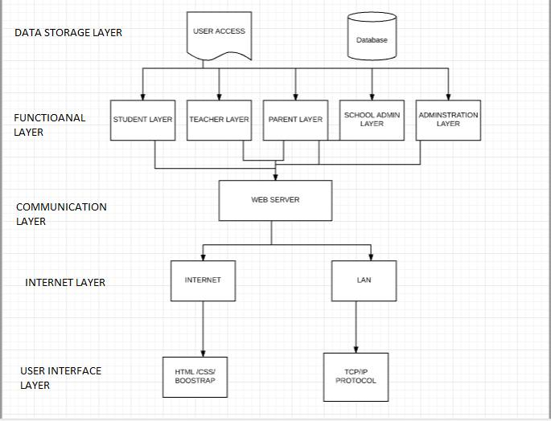

**Result/Conclusion**

Not only Parents, teacher and student but any other user who want to take admission or wanted to know the status of school gets the maximum benefit from this project.

* Students can check there daily assignment’s, attendance, courses, syllabus etc.
* Parents can check the school & children’s progress, results, updates etc.
* Teachers can upload the assignments /homework, attendance and schedules of classes etc.
* School can make their progress better and can be highlight top on the Web and getting free marketing.